
Tertiary Infotech Academy Pte Ltd
UEN: 201200696W
LESSON PLAN
For
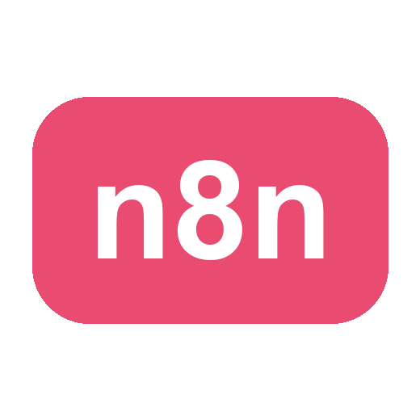
Automate Business Processes with Agentic AI Workflows
Course Code: C209
Conducted by
Tertiary Infotech Academy Pte Ltd
UEN: 201200696W
Version 2.0

DOCUMENT VERSION CONTROL RECORD
Version Number | Effective Date of Release | Summary of Included Changes | Author
1.0 | 8 August 2026 | Derived from the parent course courseware (v2.0): same topics, labs and house design. | Dr. Alfred Ang
2.0 | 19 September 2026 | Non-WSQ edition: assessment and funding content removed; both days retimed to 9:30am – 5:30pm (7.5 instructional hours/day, 15 hours total) with a 30-minute lunch break; slide references remapped. | Dr. Alfred Ang

TABLE OF CONTENTS
Course Information 4
Learning Outcomes 4
Course Schedule 5
Day 1 · 9:30am – 5:30pm — n8n, AI Agents and Agentic Chatbots
Day 2 · 9:30am – 5:30pm — Human in the Loop and RAG
Lab Reference (aligned to topics and learning outcomes) 7

Course Information
Course Title | Automate Business Processes with Agentic AI Workflows
Course Code | C209
Course Type | Non-WSQ commercial short course
Training Provider | Tertiary Infotech Academy Pte Ltd (UEN 201200696W)
Duration | 2 days · 7.5 instructional hours per day (15 hours)
Daily Timing | Day 1: 9:30 am – 5:30 pm. Day 2: 9:30 am – 5:30 pm. A 30-minute lunch break each day is excluded from instructional time.
Mode | Instructor-led, hands-on workflow-automation labs built in n8n
Trainer | Dr. Alfred Ang

Learning Outcomes
On completion of this course, learners will be able to:
- LO1: Explain what n8n and AI agents are, and build automated workflows using triggers and actions.
- LO2: Implement AI agent applications that are triggered by webhooks and integrated with business systems.
- LO3: Design agentic chatbot workflows that operate safely within business and regulatory constraints.
- LO4: Apply human-in-the-loop approval so that sensitive actions are authorised by a person.
- LO5: Deploy Retrieval-Augmented Generation (RAG) to ground an agent in an organisation's own documents.

Course Schedule

Day 1 · 9:30am – 5:30pm — n8n, AI Agents and Agentic Chatbots
Time | Duration | Topic / Activity (with slide references)
9:30–10:00 | 30 min | Welcome, trainer and learner introductions, ground rules, course outline and learning outcomes. Slides 2–12
10:00–11:00 | 60 min | Foundation — Why agentic AI: the evolution of AI, agentic vs generative AI, from RPA to Agentic Process Automation, business value and use cases. Slides 13–19
11:00–12:15 | 75 min | Topic 1 — Overview of n8n and AI Agents: what n8n is, hosting options, credentials, node types, trigger nodes, data-processing nodes, JSON and expressions, execution modes. Slides 20–32
12:15–12:45 | 30 min | Lunch break
12:45–14:00 | 75 min | Topic 1 (continued) — AI agents: the four components (model, memory, tools, instructions), popular LLM providers, model parameters and temperature, instruction design with worked examples, and MCP. Slides 33–42
14:00–15:00 | 60 min | Topic 1 (continued) — Webhooks: the inbound URL, webhook vs HTTP Request, GET vs POST, Test vs Production URL, webhook configuration and structured output. Slides 43–50
15:00–16:00 | 60 min | Hands-on Lab 1 — n8n Trigger and Action (Event Flyer with QR Code). Slides 51–54
16:00–17:15 | 75 min | Hands-on Lab 2 — Webhook and AI Agent (Marina Trust Bank Onboarding). Slides 55–57
17:15–17:30 | 15 min | Day 1 recap and Q&A
Day total: 7.5 instructional hours (9:30am – 5:30pm). The 30-minute lunch break is excluded from instructional time.

Day 2 · 9:30am – 5:30pm — Human in the Loop and RAG
Time | Duration | Topic / Activity (with slide references)
9:30–9:45 | 15 min | Day 1 recap and Q&A
9:45–11:00 | 75 min | Topic 2 — Agentic Chatbot and Human in the Loop: human in, on and out of the loop; how an approval suspends a running workflow; when a human belongs in the workflow; and guardrails. Slides 59–63
11:00–12:15 | 75 min | Hands-on Lab 3 — Chatbot Webhook (Investment Advisor): the contact gate and the four compliance probes. Slides 64–66
12:15–12:45 | 30 min | Lunch break
12:45–14:15 | 90 min | Hands-on Lab 4 — Human in the Loop (Client Rapport Assistant): the approve and decline paths. Slides 67–69
14:15–15:30 | 75 min | Topic 3 — Retrieval-Augmented Generation: why retrieval rather than a bigger prompt, the RAG pipeline, tokenization and embeddings, chunking, vector stores and grounding. Slides 71–79
15:30–17:00 | 90 min | Hands-on Lab 5 — RAG Customer Care Chatbot (Cook & Bake Academy): ingestion and the grounded chatbot. Slides 80–83
17:00–17:30 | 30 min | Course recap, taking it back to work, Q&A. Slides 84–86
Day total: 7.5 instructional hours (9:30am – 5:30pm). The 30-minute lunch break is excluded from instructional time.
Total instructional time across the course: 15 hours (2 days × 7.5 hours).

Lab Reference (aligned to topics and learning outcomes)
Topic | Outcomes | Labs | Deck slides
Topic 01: Overview of n8n and AI Agents | LO1 · LO2 | Lab 1, Lab 2 | Slides 20–58
Topic 02: Agentic Chatbot and Human in the Loop | LO3 · LO4 | Lab 3, Lab 4 | Slides 59–70
Topic 03: Retrieval-Augmented Generation (RAG) | LO5 | Lab 5 | Slides 71–83

